Jonathan Oen

PID: A14547654

**Module 3 Write Up**

**3.3.1.a**

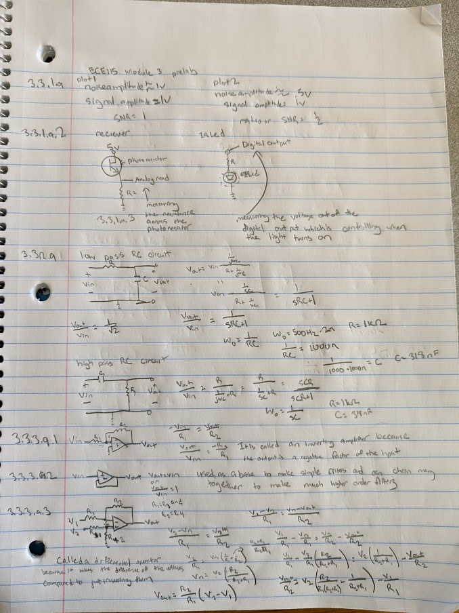

**3.3.1.b.**

Results of the IR sensor circuit

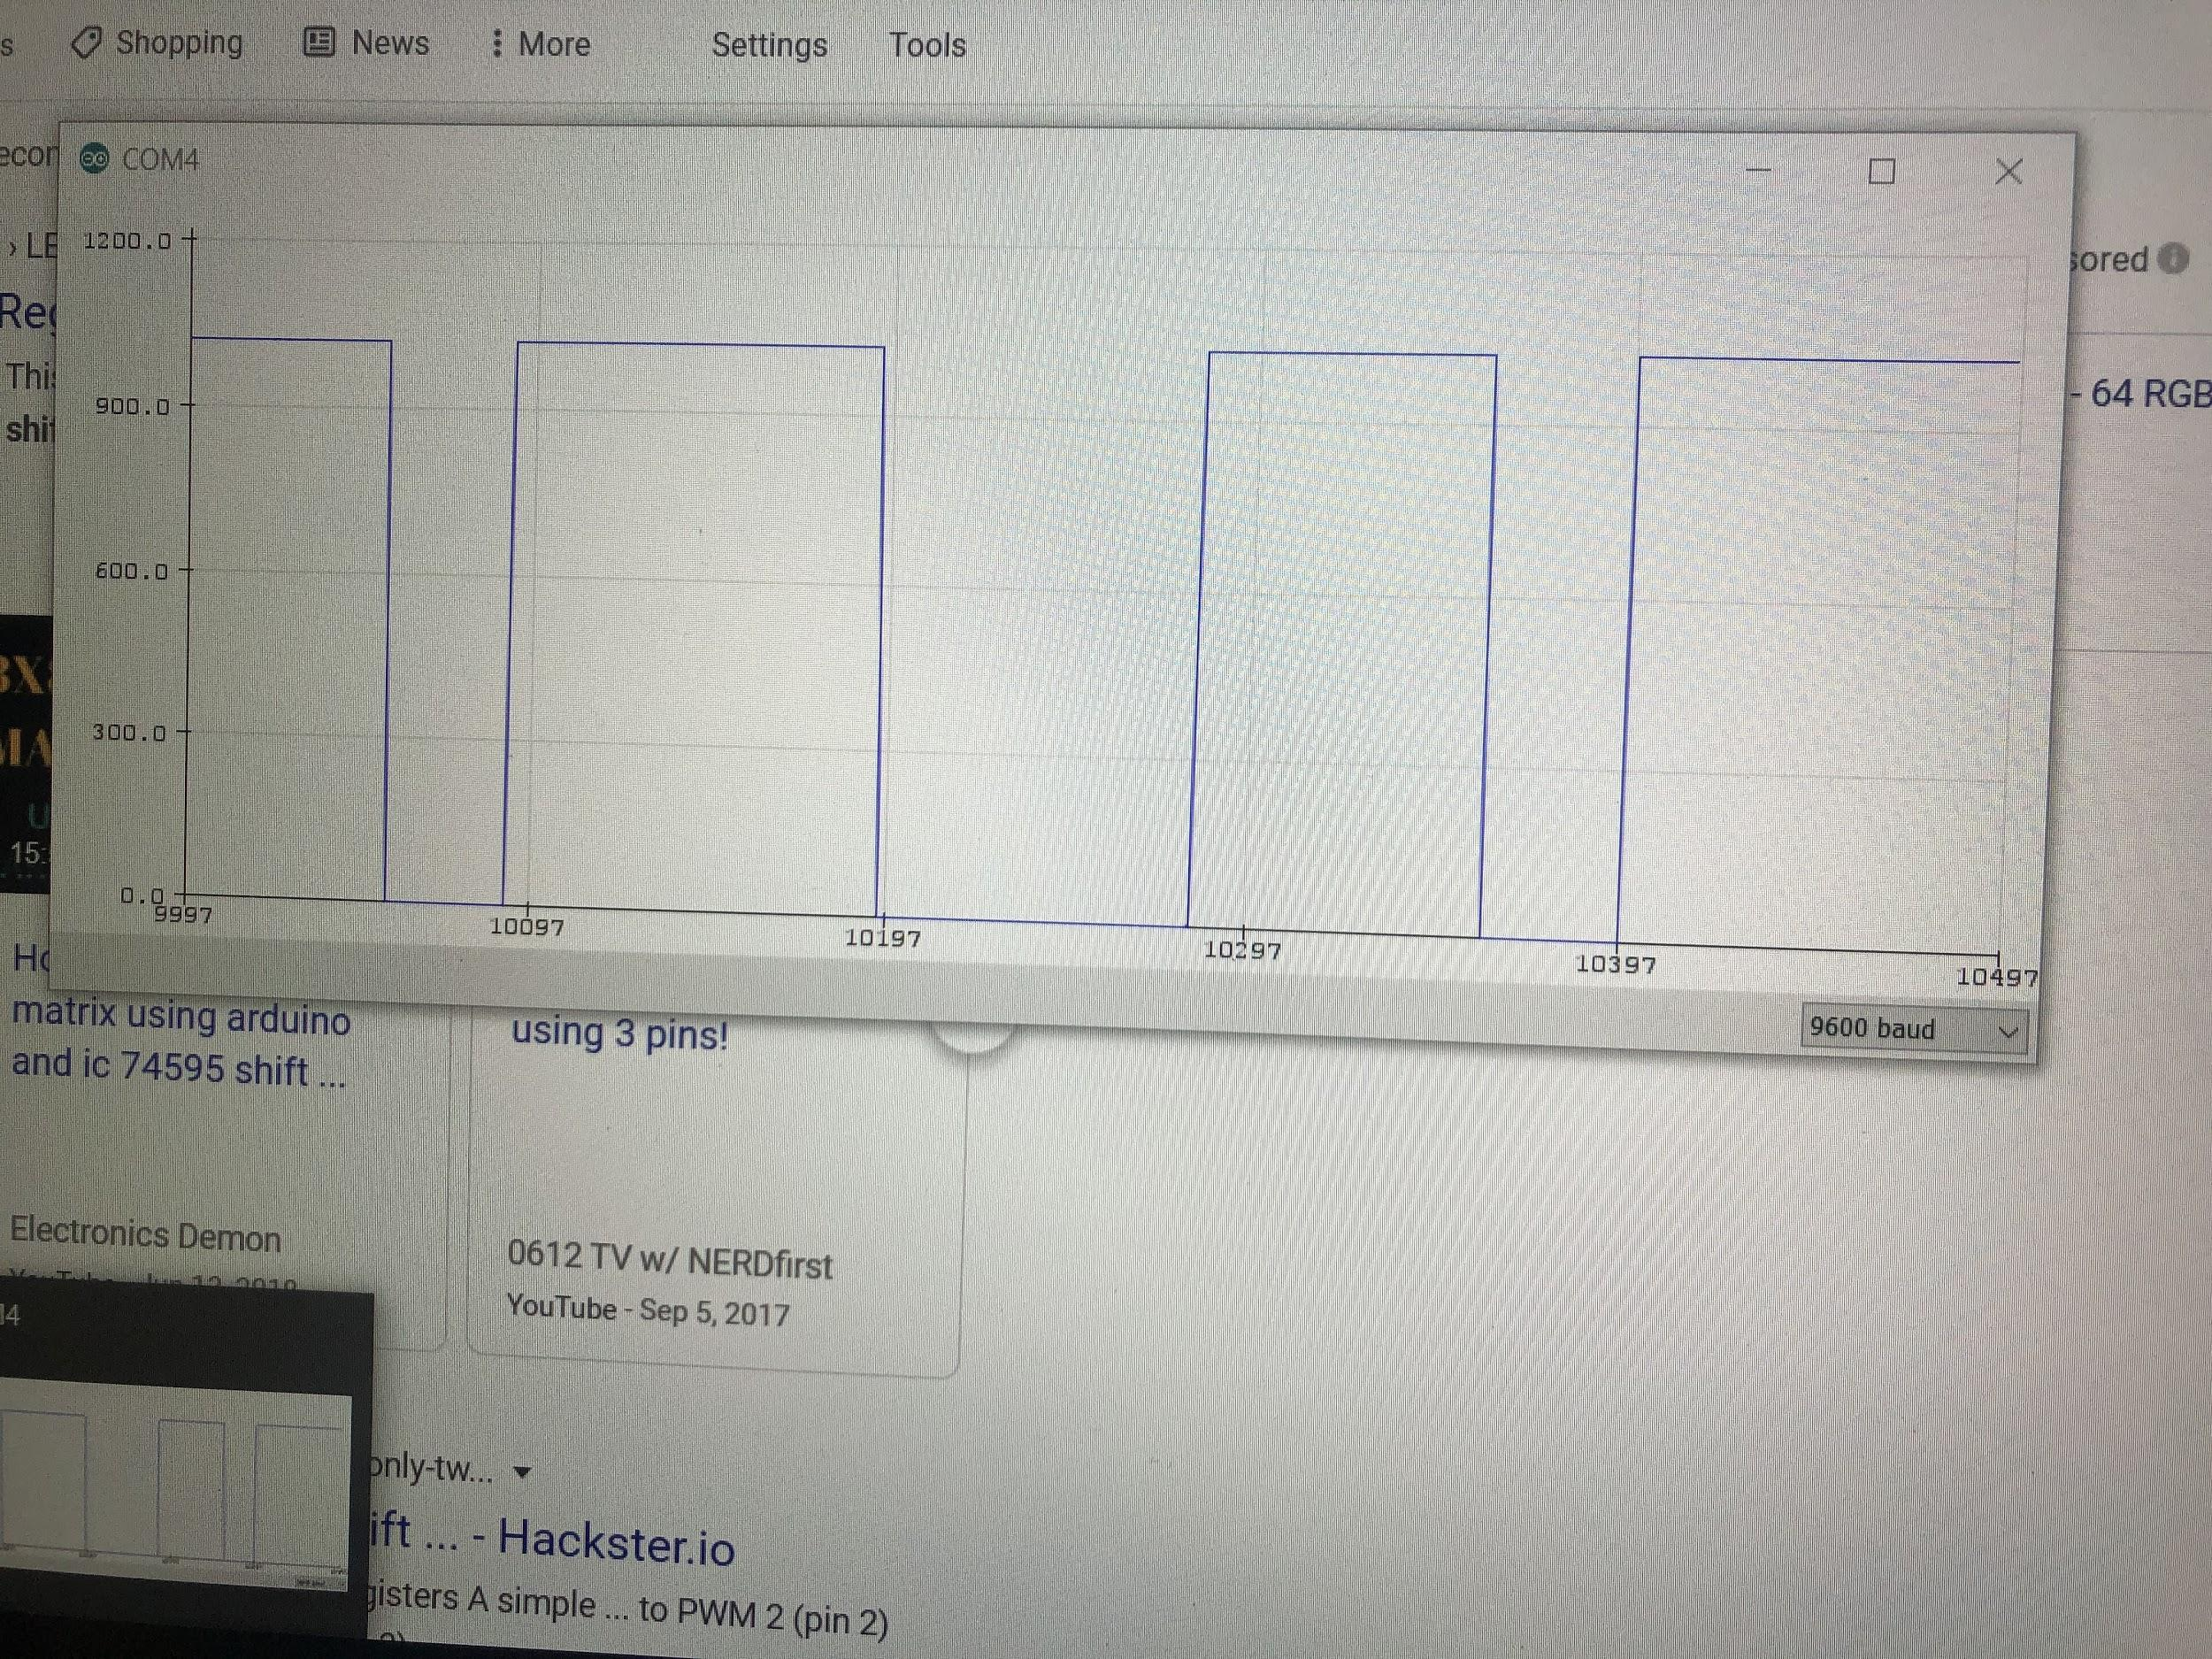

IR sensor reading high or low

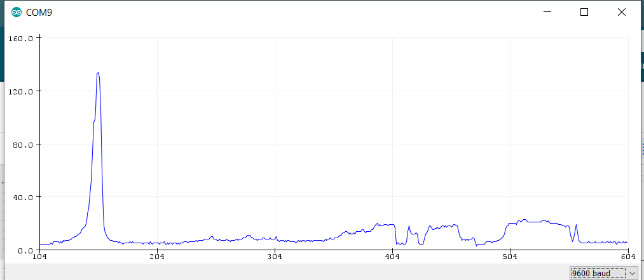

Detects an object at about 8cm

**3.3.2.a**



Low-pass filter

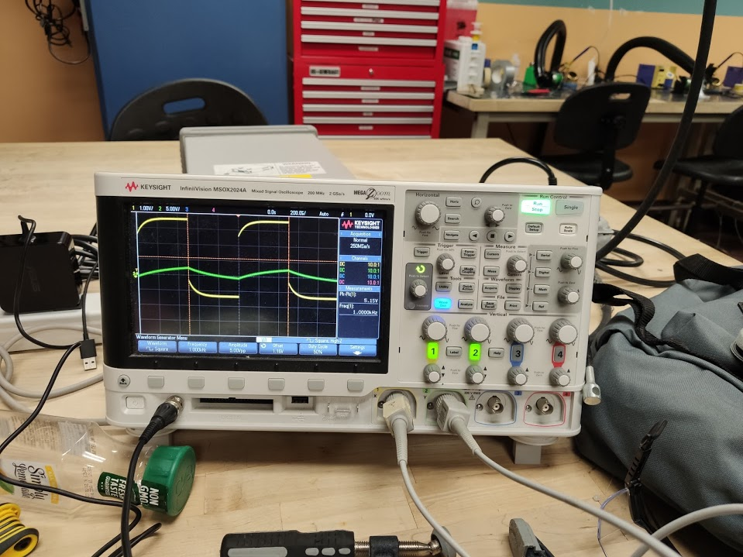

We want to use a lowpass filter to filter out the high frequencies and preserve our DC offset.

High pass filter

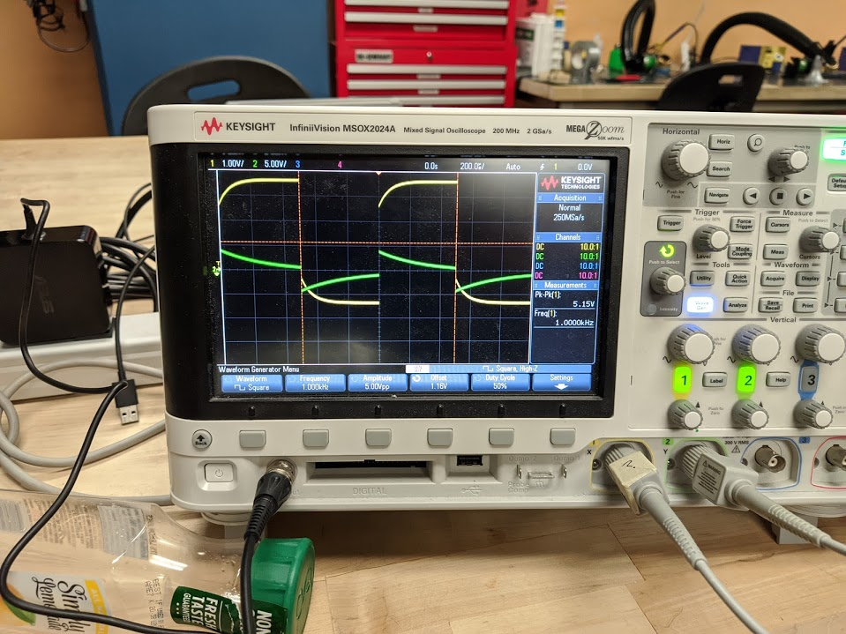

**3.3.2.b**

IR sensor unfiltered

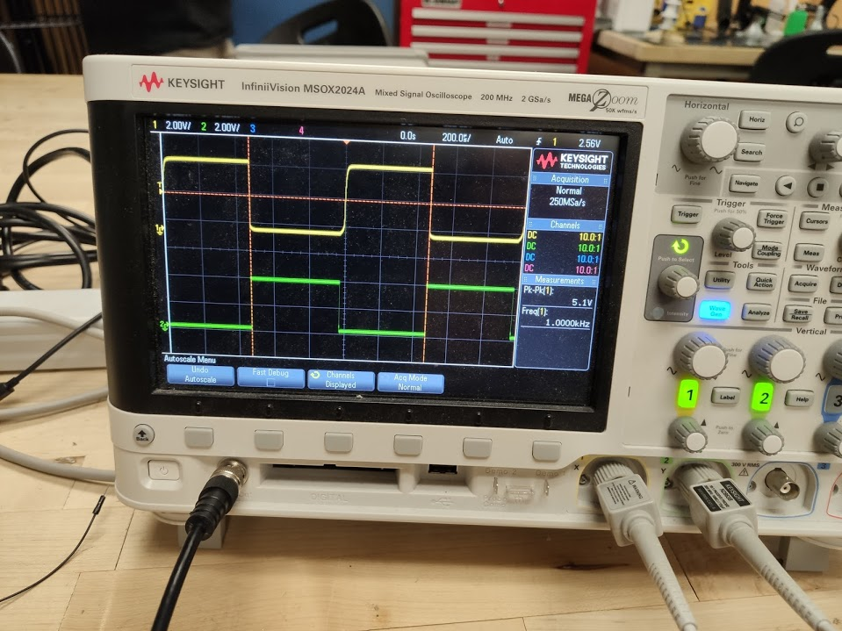

5.1 V peak to peak

IR sensor with a high-pass filter

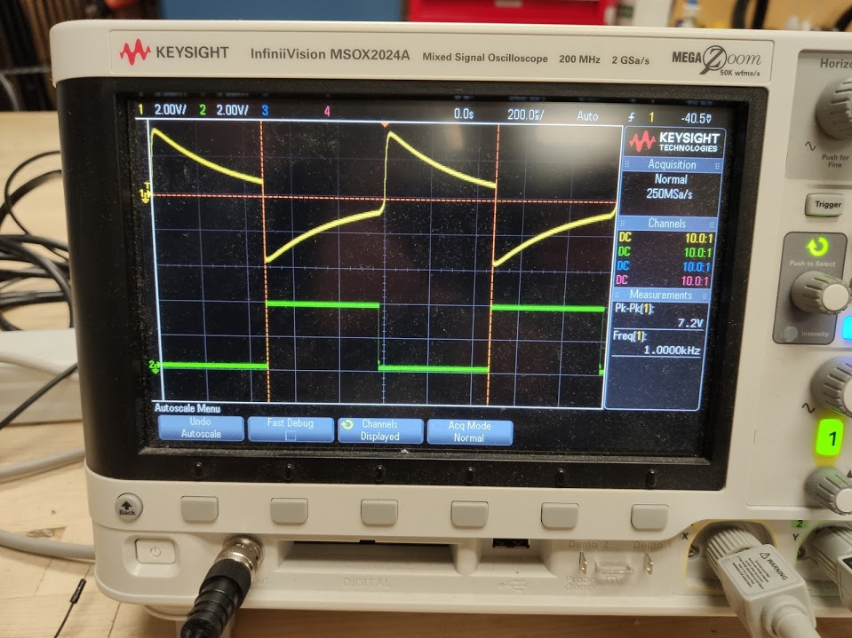

7.2 V peak to peak

**3.3.3.a**



**3.3.3.b**

Amplified voltage by 10x

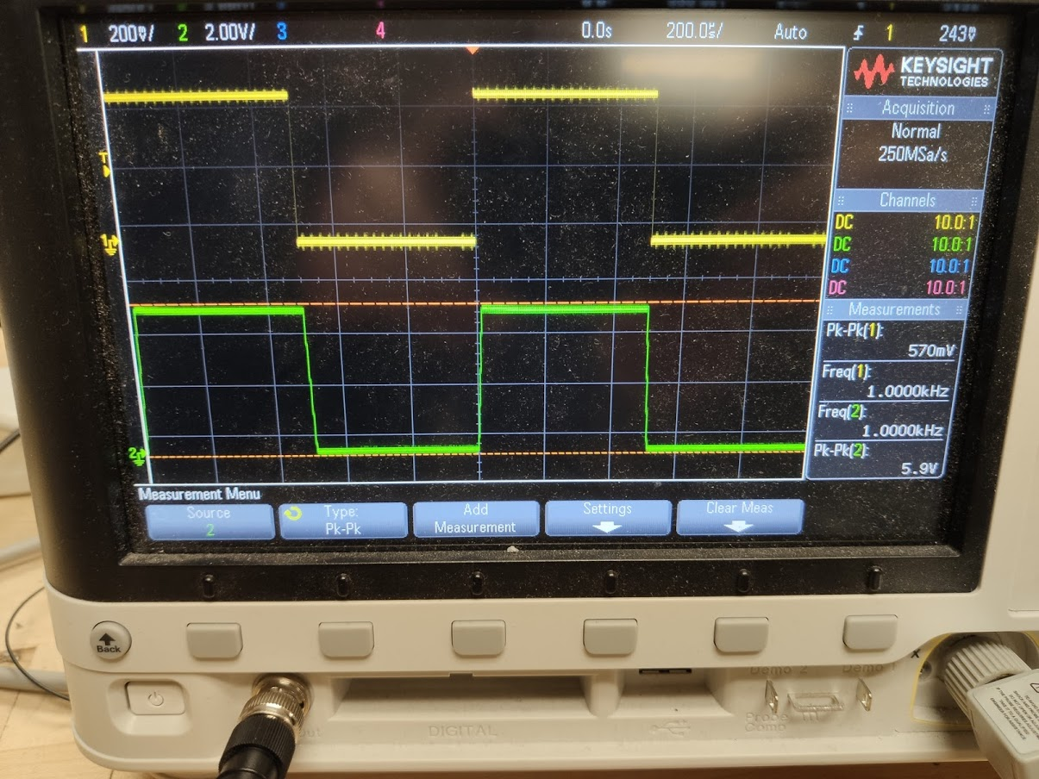

The voltage gets clipped by the saturation which is 15V and can’t go any higher due to that. Other than that, we successfully built a voltage follower that amplifies the signal 10x

**3.3.3.c**

Comparator design

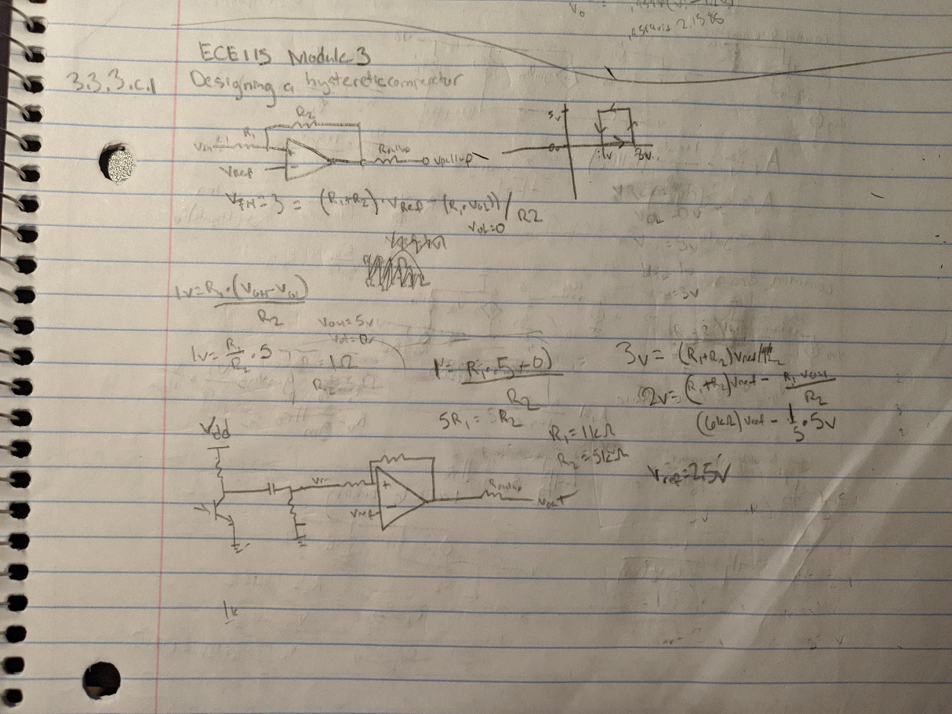

Comparator with Hysteresis XY plot

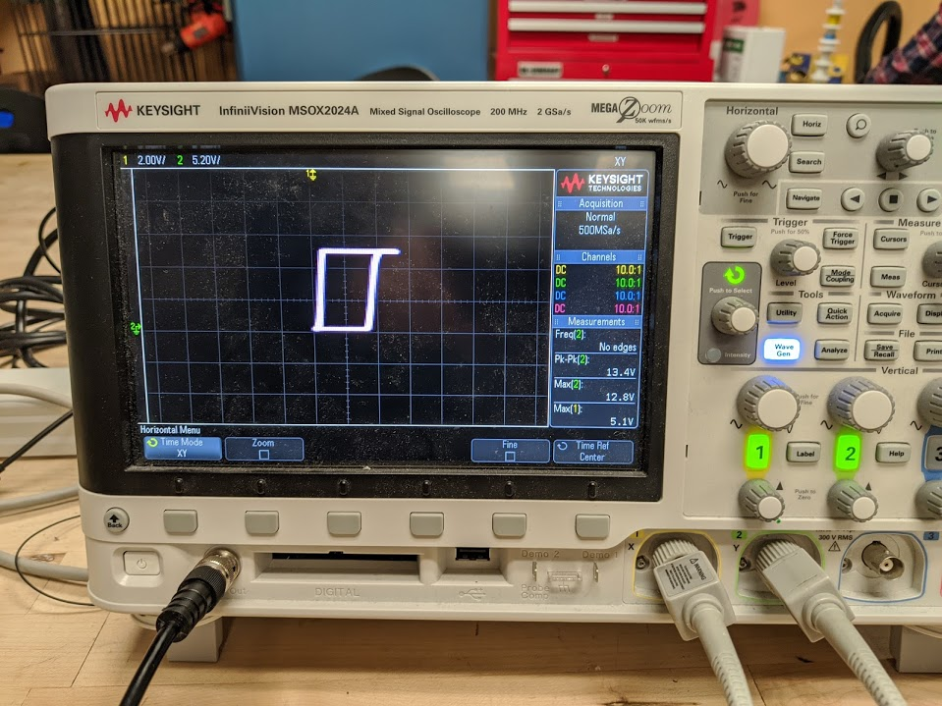

Implementation of Comparator to convert analog values from the sensor to digital ones

(Comparator circled in blue)

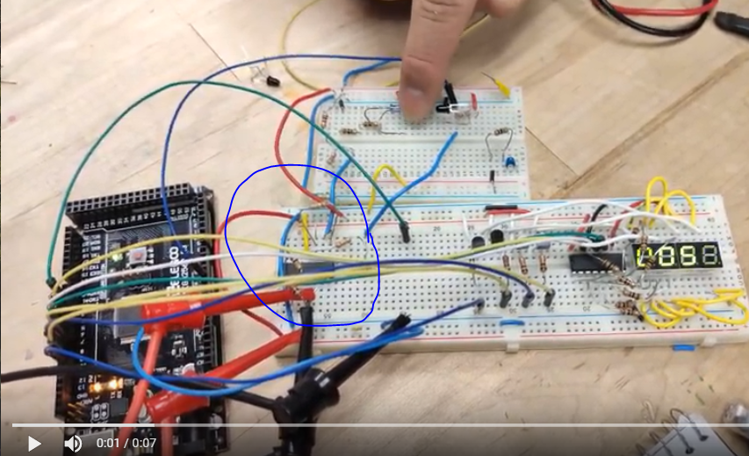

**3.3.4.a.1**

Proximity Sensor System circuit diagram

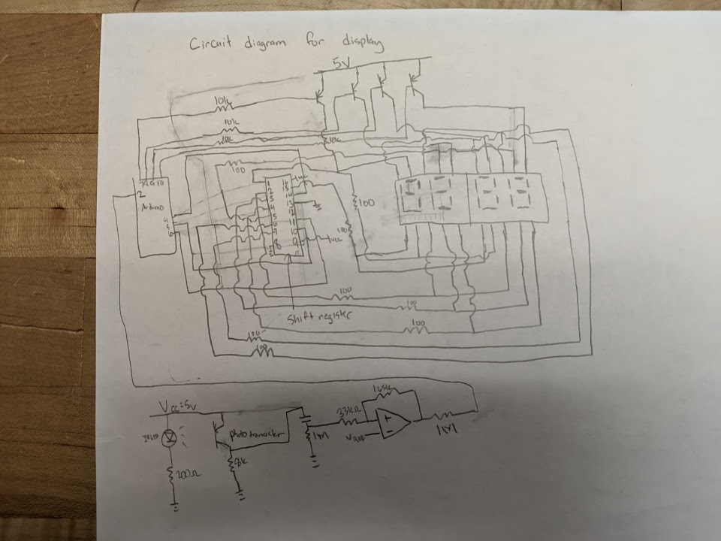

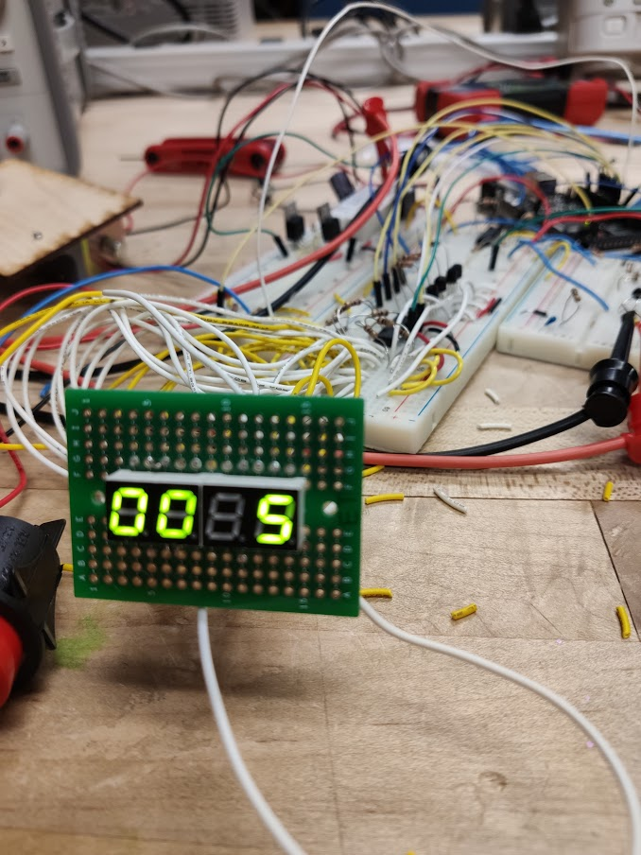

3rd digit is off, because the camera shutter speed isn’t fast enough

Code block diagram

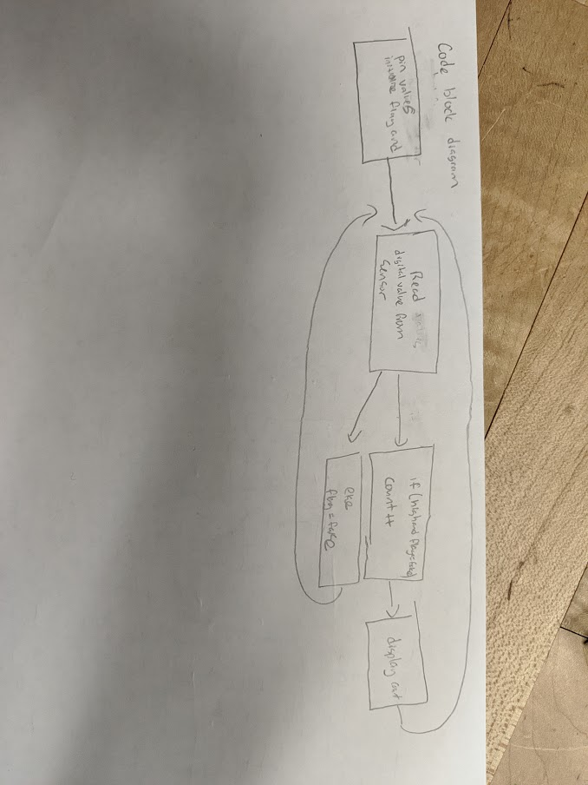

**3.3.5**

Complete Circuit Diagram



Testing CAD

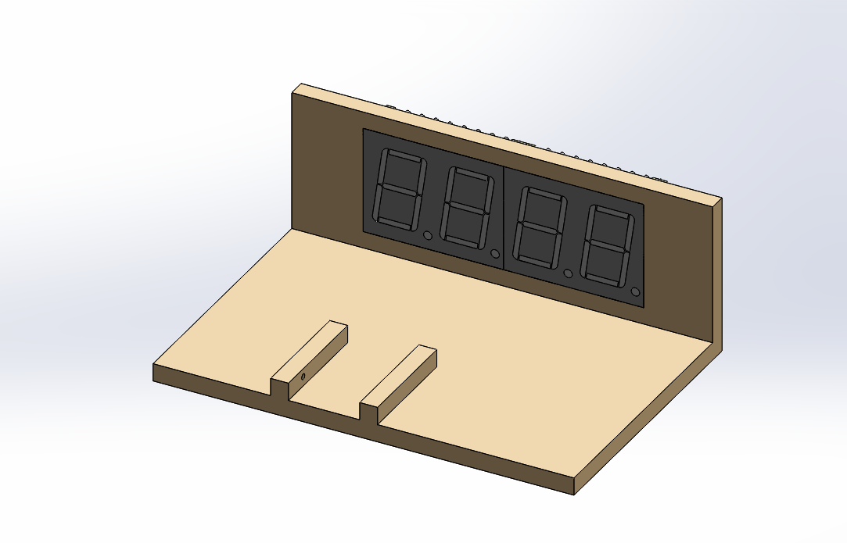

Whole system

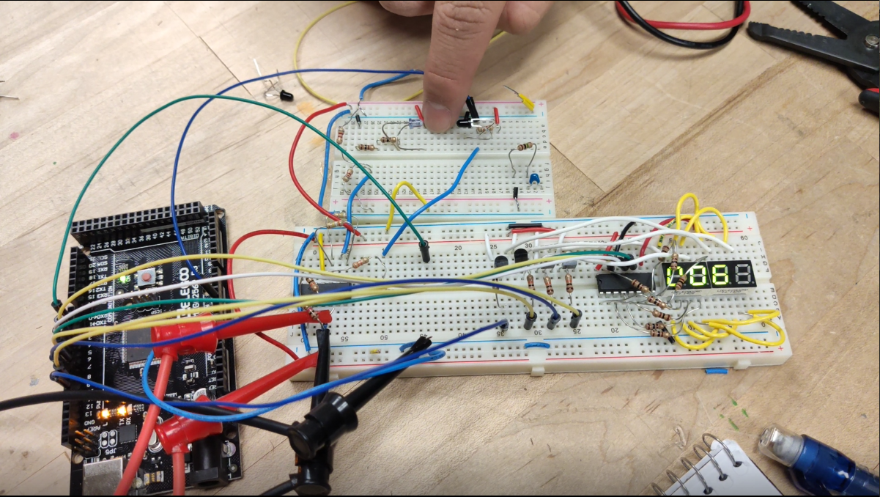

**Design Specifications**

1) Able to detect ball rolling past and counting on the 7 segment display

2) Phototransistor detecting the ball at x distance

3) Able to count up to 100

|  |  |  |  |  |  |
| --- | --- | --- | --- | --- | --- |
| **Specification Number** | **Specification Description** | **Test to perform** | **Relevant requirement** | **Specification [units]** | **Measured**  **Values**  **[units]** |
| **1** | Detection of the ball rolling past the sensor and incrementing the display | Numbers counted | 1,3 | 100 points | 9999 points |
| **2** | Photosensor detecting the IR LED | Moving an object as far as possible to find out the range | 2 | 10 cm | 8 cm |

**Redesign notes**

Currently, the wires coming out of the protoboard are a mess and have mis-matched length. This ended up messing with our original circuit and ultimately ruining our electronics on our system and causing our display not to work. Our current plan is to cut our wires such that they have matching lengths and to redo our circuit such that there are fewer wires sticking out of the breadboard. Other than that, our system worked to perfection, with the sensor and display working perfectly as planned before the mishap.